**We have some request configurations of cameras in the “Request setting of camera.rar”. You can just follow these samples. The firmware`s version and setting is very important for the test.**

**Requests of the digital signage:**

1. **The OTA version should be “3.0.0”. You can get it from FTP:** **/00 Oversea Products/06 Transmission_Display/02 Commerical Display/02 Digital Signage/04 Firmware/Digital Signage/Digital Signage 3.0.0/二代/. (You can use lite to upgrade the signage at terminal management)**
2. **Then upgrade the apk which I sent to you. Check the version of the Focsign player is V3.0.0 build 20200513.**

**You can just click the right middle edge in the Focsign Player. There should be a pop-out menu. Choose the last one to check the version.**

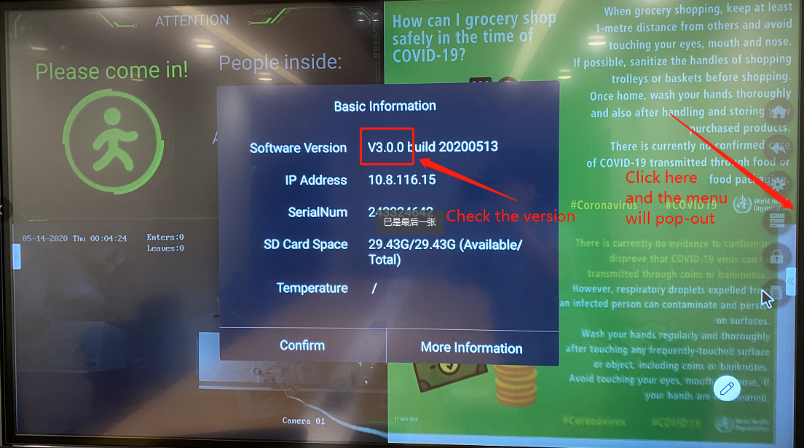

**Set a static IP for the digital signage and your PC!!!**

**Keep the Focsign Player open in the signage!!!!**

1. **Install the Focsign Lite which I sent to you.**
2. **Disable the firewall.**
3. **Enable only one network adapter, disable the others please !!!!**
4. **Open the Focsign Lite and set the password of your client.**
5. **Add the digital signage.**

**(1). If your device is in same network area with your PC. Follow these step:**

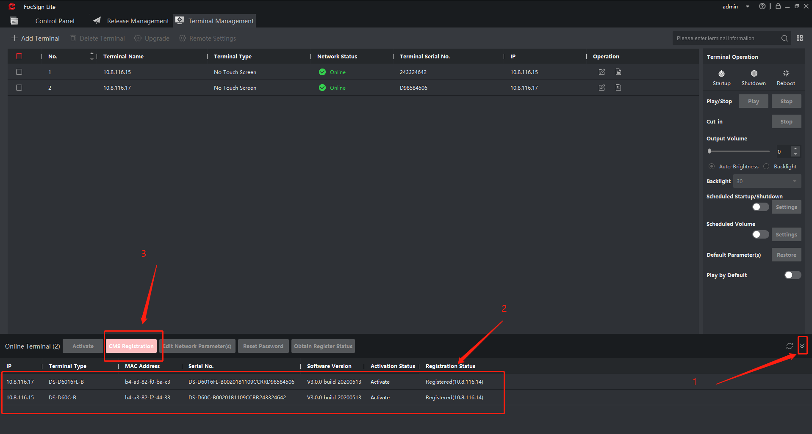

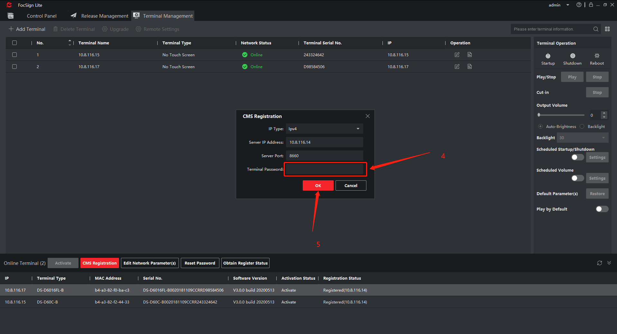

**(2) If you device`s IP is not in the same network area, you can add the signage like these.**

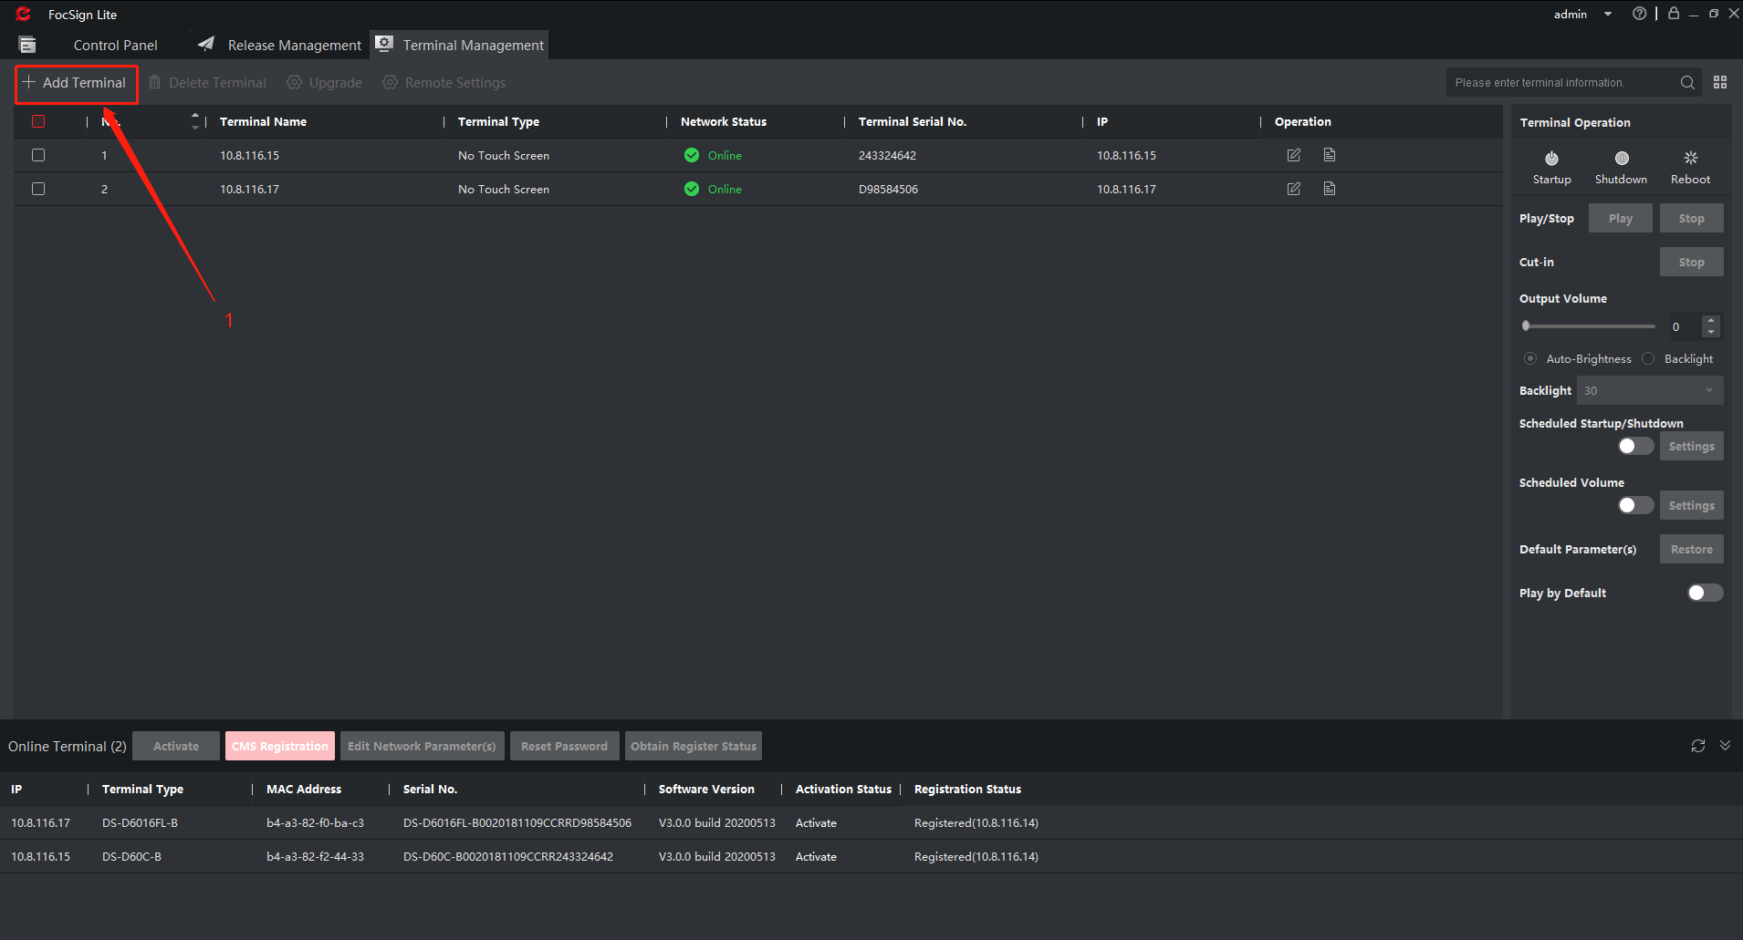

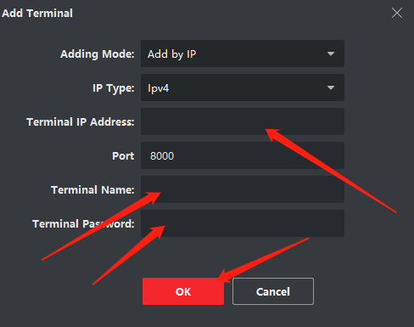

**(Remember, if you change your PC`s IP. The entire system will be offline. You need to add them again.)**

1. **Make program.**
2. 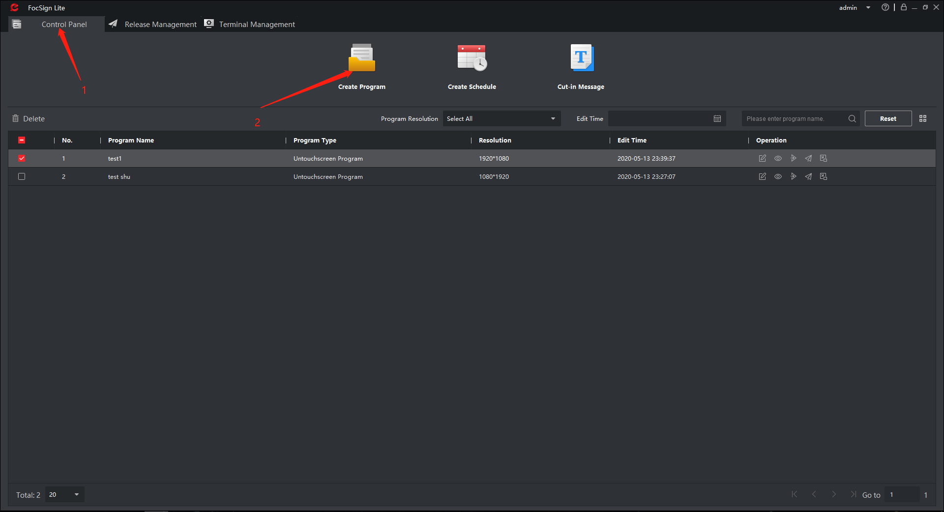
3. 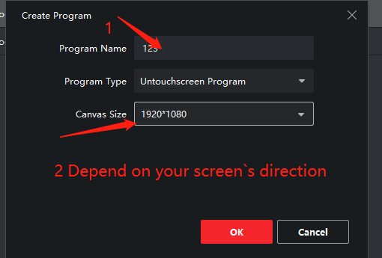
4. 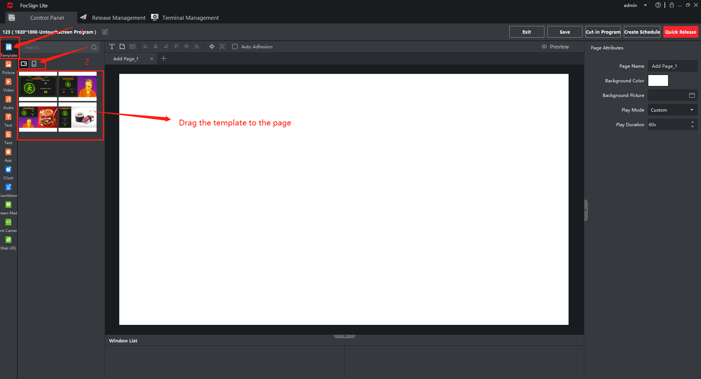
5. 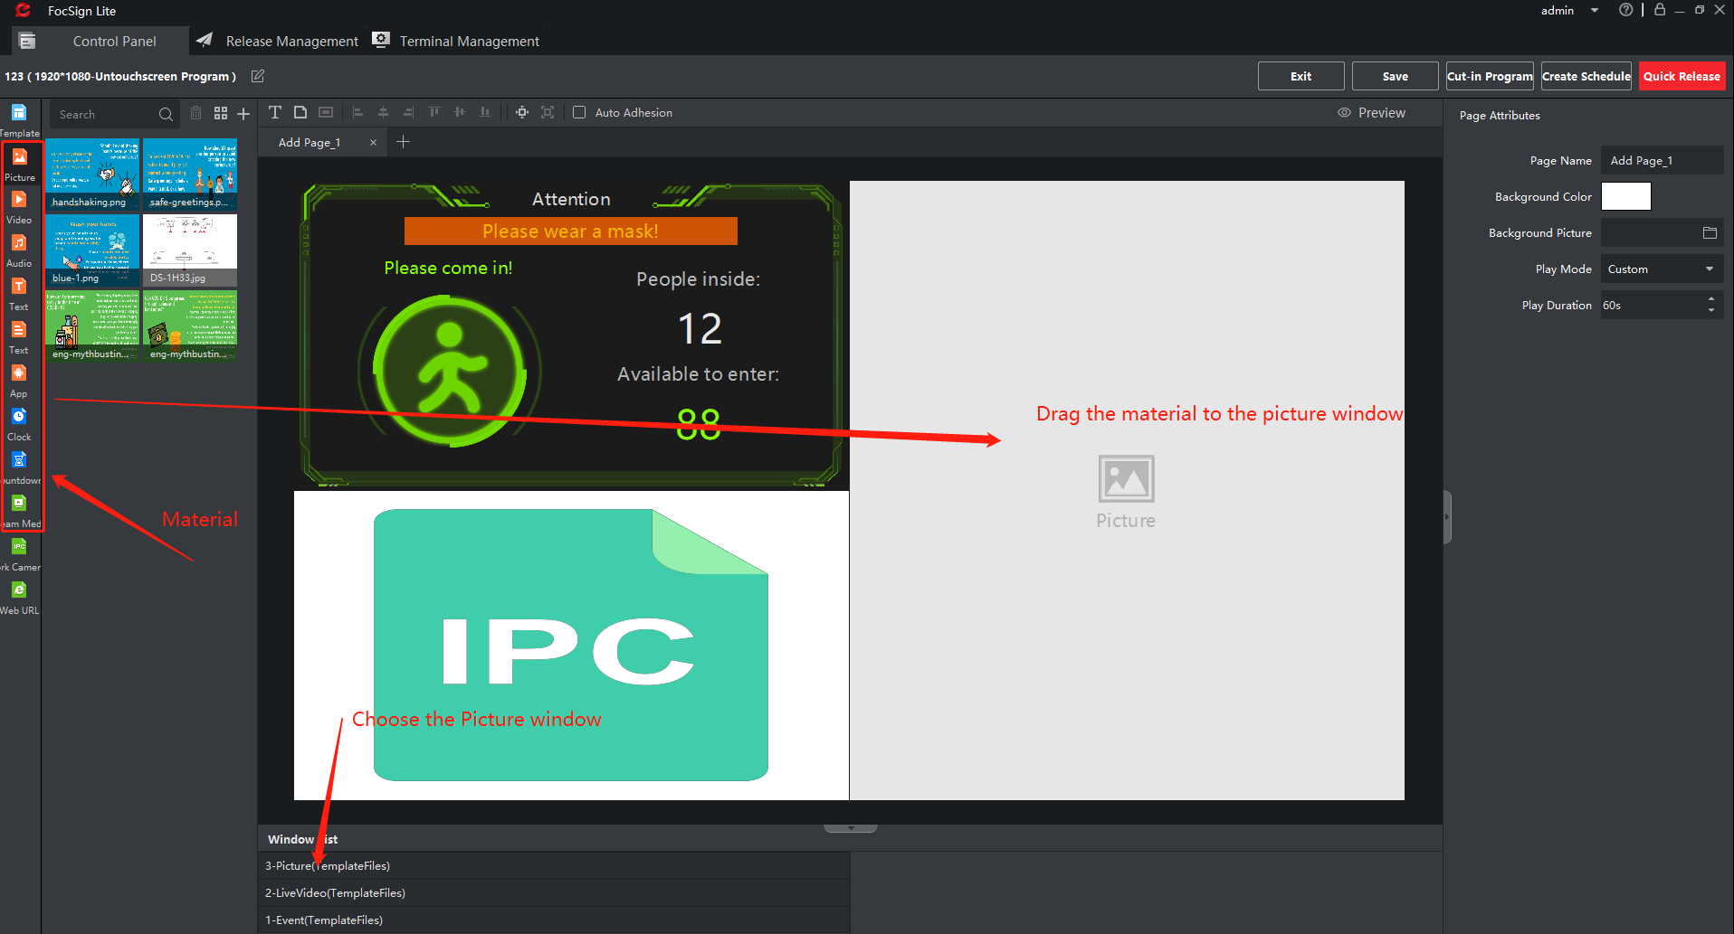
6. 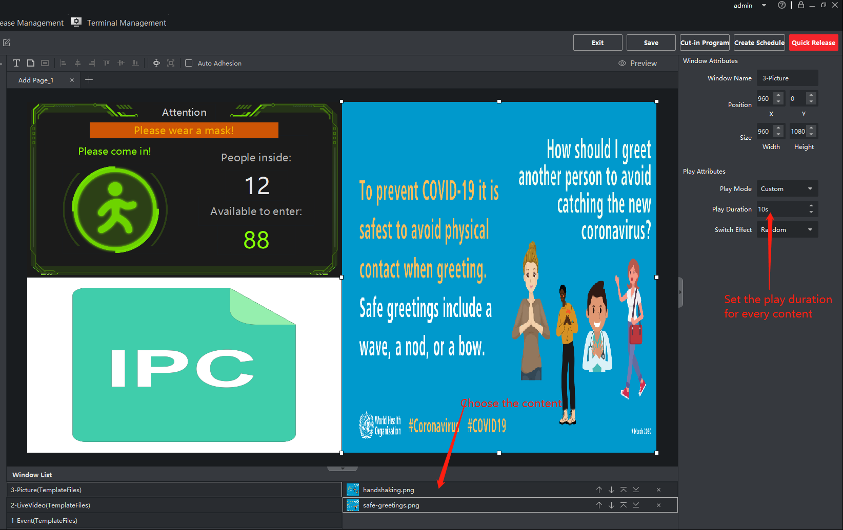
7. 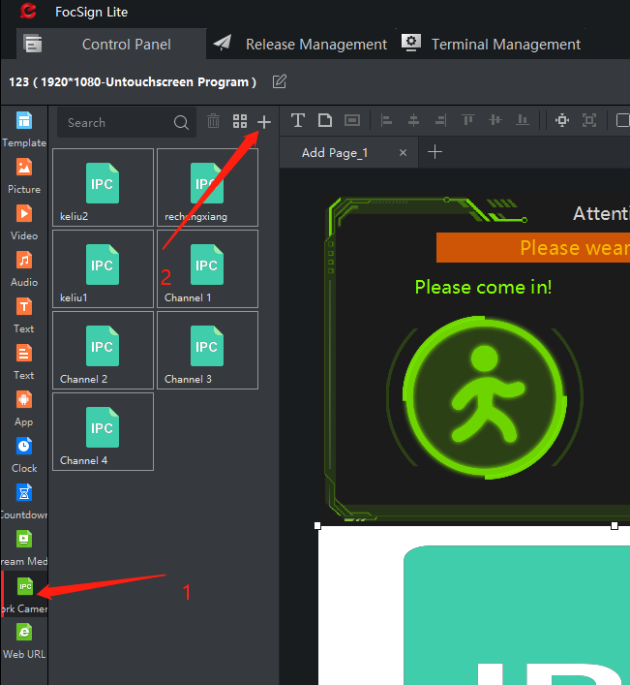
8. 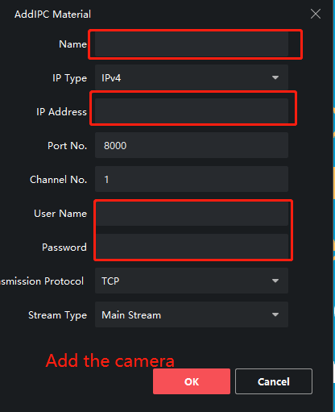
9. 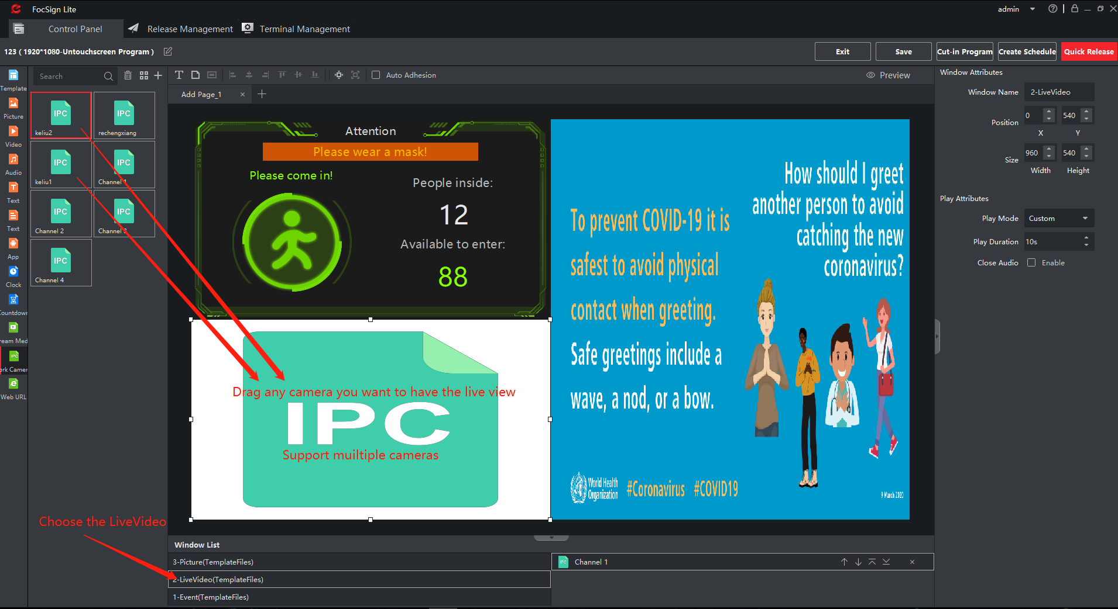
10. 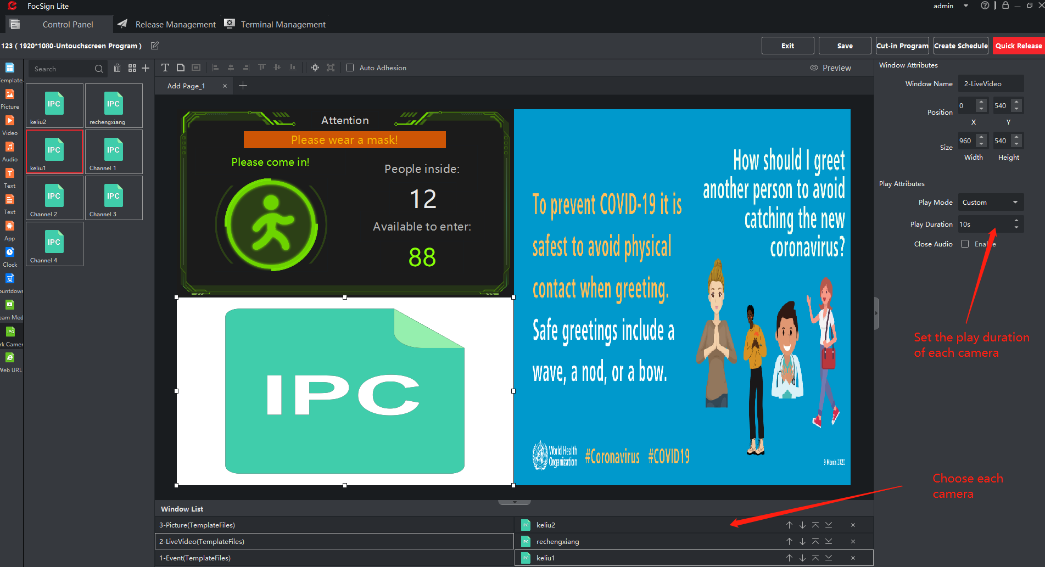
11. 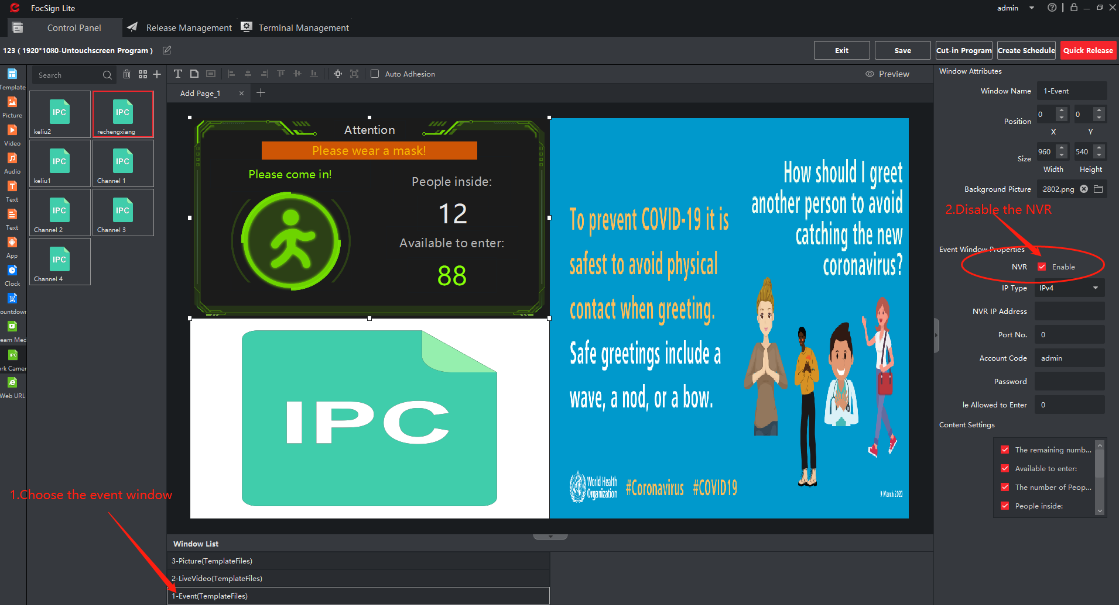
12. 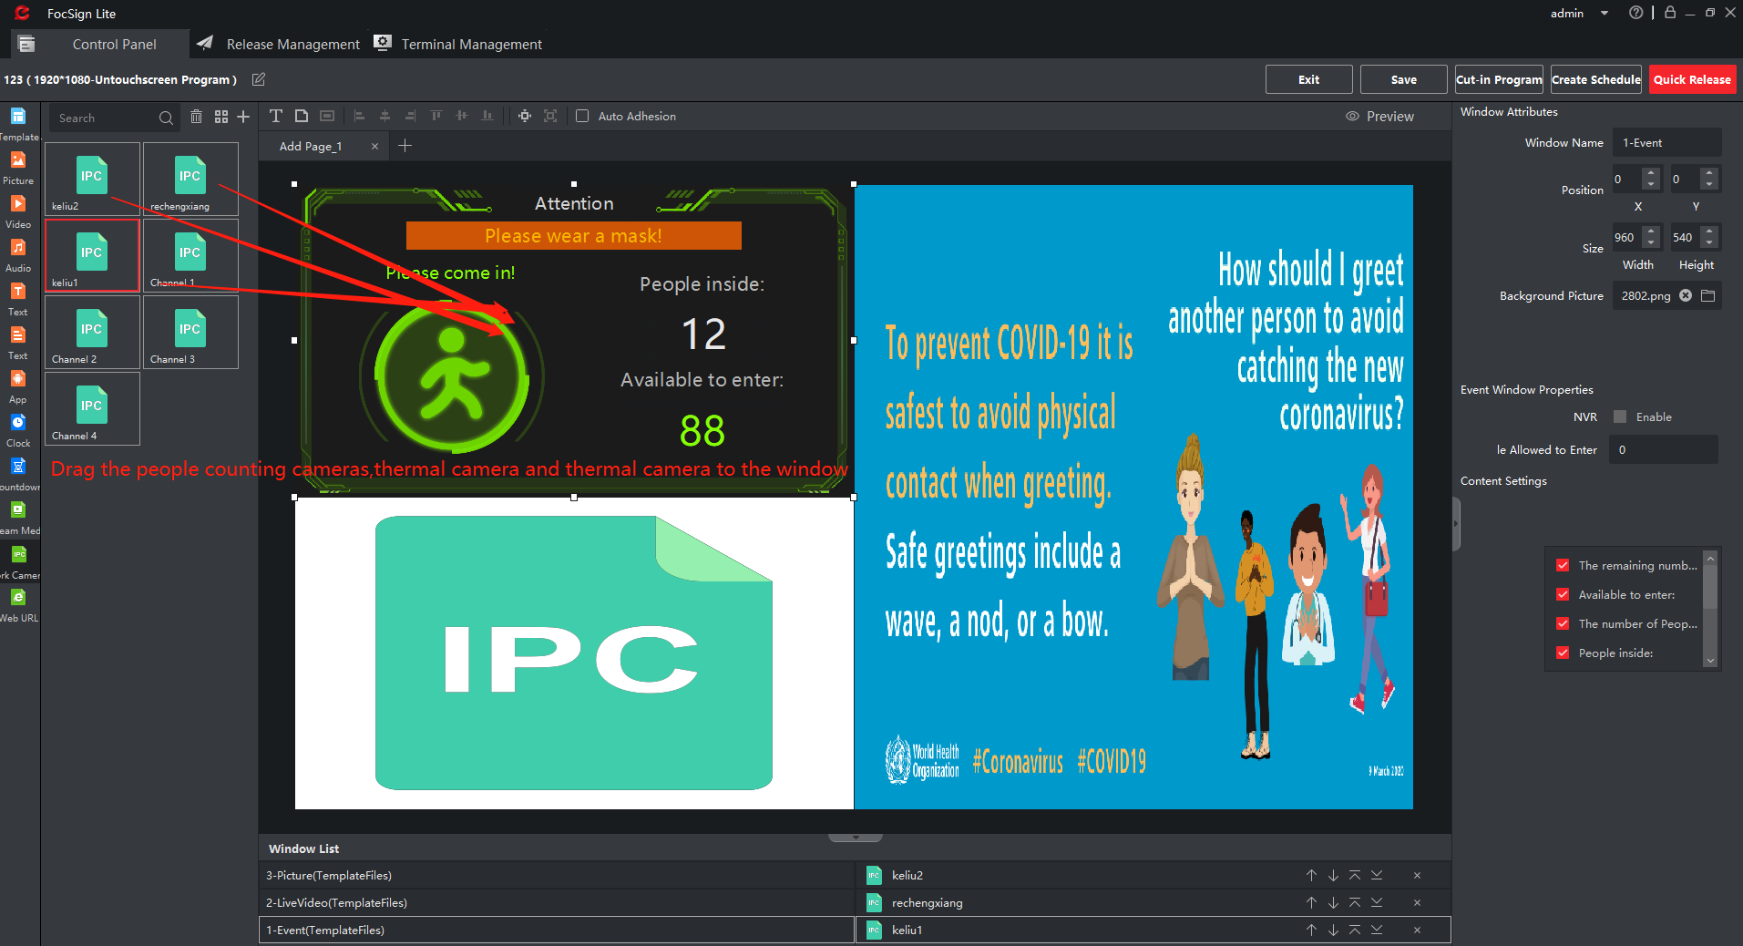
13. 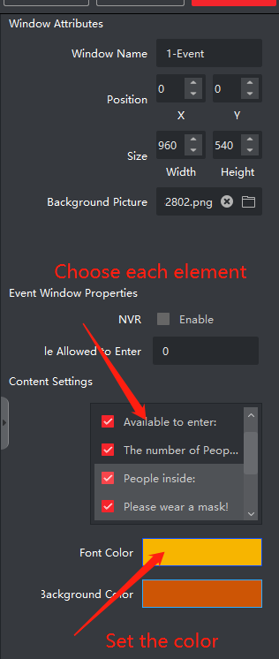
14. 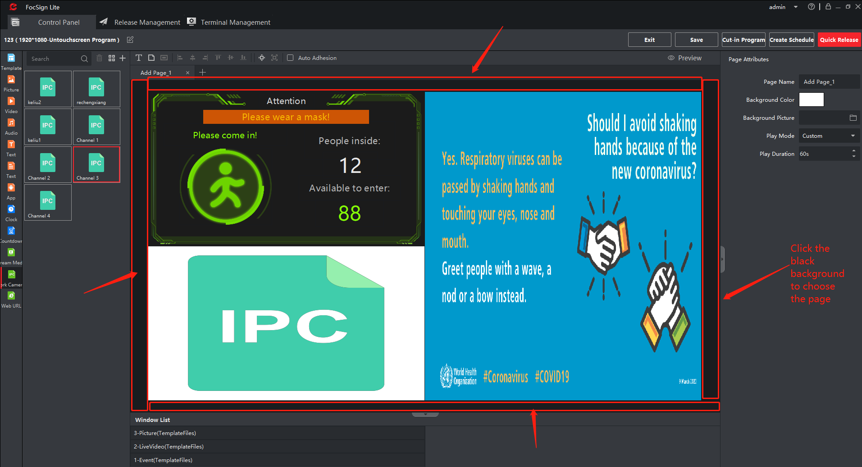
15. 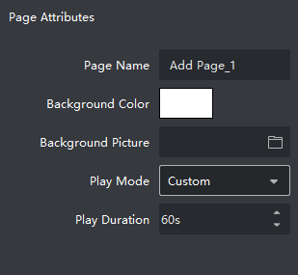

**For test, I recommend you use the loop play mode.**

1. 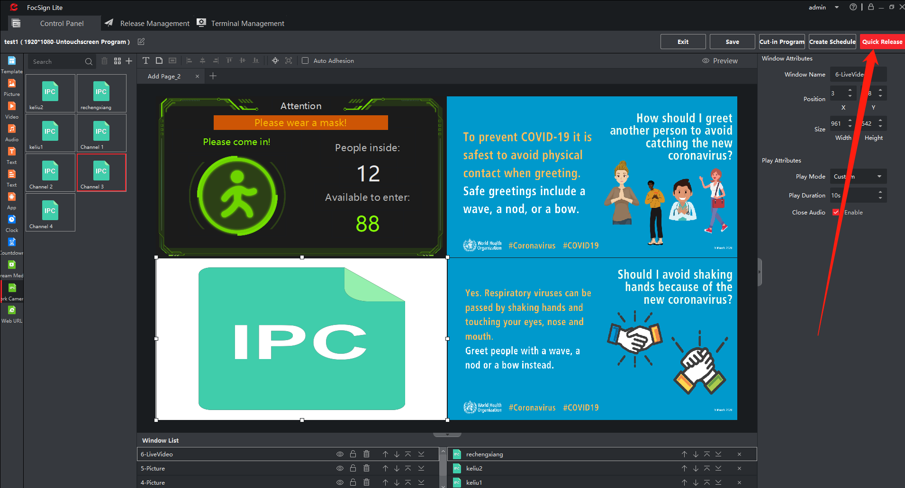
2. 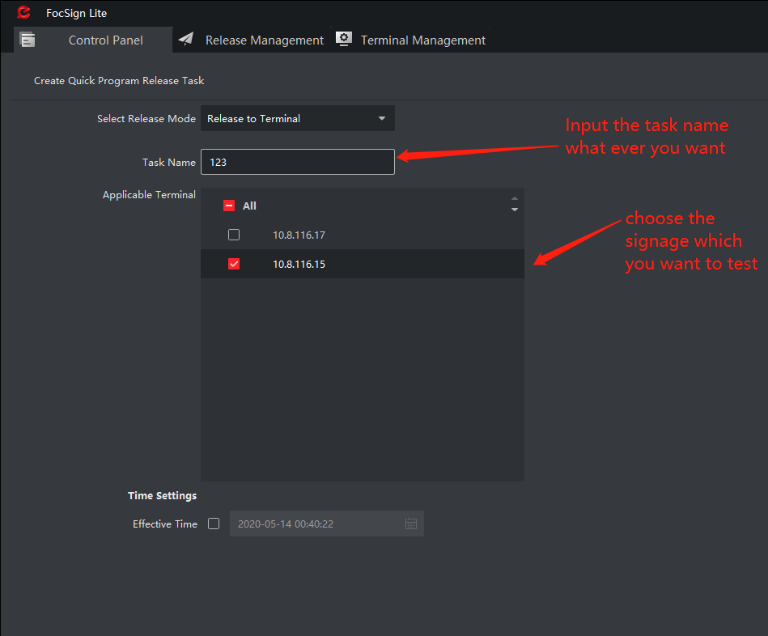
3. 